End to End Machine Learning project

## Tutorial 1: GitHub & Code setup

* Steup a new environment
* Setup.py
* Requirements.txt
* Steps:

1. Create a new repository “mlproject”
2. Create a new folder in which entire project will be developed
3. Copy the path of the folder & open anaconda prompt
4. Code . this will open vscode
5. First we need to make sure that we are in sync with the GitHub repository
6. Open new terminal in vs code and create new environment

(select cmd in terminal and use below command)

conda create -p venv python==3.8 -y

activate the virtual environment

conda activate venv/

1. Clone the repository and sync with GitHub

* Initialize git repository (git init)
* Add README.md file, before adding create README.md file (either in git or in vs code) (in README.md file we can write descriptions, what are all the steps required)
* Add README.md file in GitHub repository

git add README.md

commit the file,

git commit -m "First commit"

* Push the file to git repository

git branch – M main

* Add origin (so it is in sync with the GitHub repository)

git remote add origin <https://github.com/AD/mlproject.git>

git remote – v

to push the data into github repo we need to set git global

(check git global config and add username and email of your own)

git config --global user.name "John Doe"

git config --global user.email johndoe@example.com

* Push the data

git push -u origin main

by this now we can see the file in GitHub repository.



* Create a new .gitignore file in GitHub repository, select python and commit changes

git pull   
  
so all the updation will be done in vscode as well.

* Setup a setup.py and requirements.txt

(setup.py will be responsible for making or ML application as a package, which can be used further.)

from setuptools import find_packages , setup #find all the packages

setup (

    name = "mlproject",

    version = "0.0.1",

    author= "yourname",

    author_email= "youremail id",

    packages=find_packages()

    install_requires = ['pandas', 'numpy', 'seaborn '] #automatic installation can be done

)

* Create a new folder “src” in vs code (source) and inside it create __init__.py
* When in setup.py find_packages() is running it will go and find in how many files have __init__.py running. Considering source as a package , it will try to build it.

1. We create a function , when we need to install many packages,

get_requirements () #which will take requirements.txt it should be able to read all those files.

def get_requirements (file_path:str)-> List[str]:

    '''

    this function will return the list of requirements

    '''

    requirements = []

    with open (file_path) as file_obj:

        requirements = file_obj.readlines()  #the line will get readed, but \n will get added

        requirements = [ req.replace("\n","") for req in requirements.txt]  #replace \n with blank

Here -e. will automatically trigger setup.py

When we install requirements.txt the setup.py will also run.

To solve the above problem use :

pip install -r requirements.txt

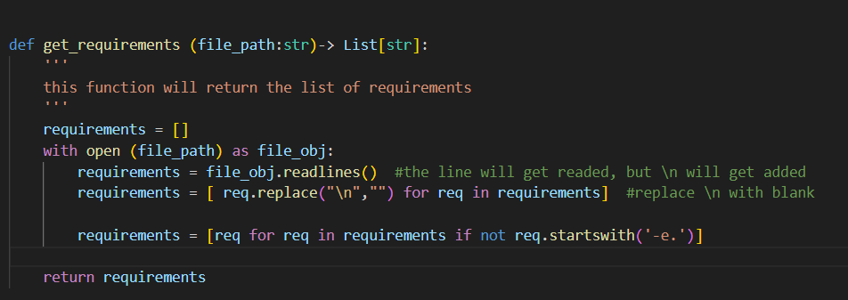

Build is happening,

mlproject.egg-info will tell us the packages which are getting installed.

We have also created a source folder and build the packages.

Add the files – git add .

git commit -m “setup”

git push -u origin main

## Tutorial 2: Project structure, Logging, & Exception Handling

* Create components folder in “src” in that folder again create __init__.py file.
* Create data_ingestion.py file (which will be for reading the data)
* Create data_transformation.py file (for data transformation)
* Create model_trainer.py file (for model training )
* Create pipeline folder in “src” and create train_pipeline.py file
* Create “__init__.py” and “predict_pipeline.py” file in pipeline folder.
* Create logger.py, exception.py and utils.py file in “src” folder.

(check exception handling python documentation)

* Create function & class of your won to do exception handling (exception.py)

#we are going to write our own exception

############ exception handling ############

import sys

#the sys module in python provides various functions and variables that are used

#  to manipulate different parts of the python runtime environment

def error_message_details(error, error_detail: sys):  #error_details will be present in sys

    _, _, exe_tb = error_detail.exc_info()

    file_name = exe_tb.tb_frame.f_code.co_filename  #to get the filename

     #execution info, this will give us three info we are interested in the last one.

    #on which line exception has occured, in which file exception  has occured

    error_message = "Error occured in python script name [{0}] line number [{1}] error message [{2}]".format(file_name, exe_tb.tb_lineno, str(error))

    return error_message

    #whenever error occurs we are going to call this function.

#created own exception class

class CustomException(Exception):

    def __init__(self, error_message, error_detail:sys):

        #inheriting from exception

        super.__init__(error_message) #inherit exception class

        self.error_message = error_message_details(error_message, error_detail= error_detail)

#whenever we raise custom exception, it is inheriting from parent exception, whatever error msg is coming,

# it will initialize and gets assigned to a class variable

    def __str__(self):

        return self.error_message   #to print the error message is called.

* Similarly do in logger.py file.

Logger.py file will be used to log the information.

Create log file.

import logging

import os

from datetime import datetime

#create log file

LOG_FILE = f"{datetime.now().strftime('%m_%d_%Y_%H_%M_%S')}.log"

logs_path = os.path.join(os.getcwd(), "logs", LOG_FILE)

#whatever logs will be created it will be respect to current working directory.

#logs folder will get created,

os.makedirs(logs_path, exist_ok=True) #even when there is file, keep on appending it.

LOG_FILE_PATH = os.path.join(logs_path, LOG_FILE)

#whenever we want to create the log, we have to set this up in basic config

#give the file name, where you want to store it

#format

#which level

logging.basicConfig(

    filename = LOG_FILE_PATH,

    format = "[%(asctime)s] %(lineno)d %(name)s - %(levelname)s- %(message)s",

    level = logging.INFO,

)# any print msg will use this config, wrt msg

If __name__ == “__main__”:

Logging.info(“Logging has started”)

If we run the logger.py file, it gets executed successfully, and logs gets created as below”:

* Similarly check for exception.py file

(add below code in exception.py)

import logging

if __name__ == "__main__":

    try:

        a = 1/0

    except:

        logging.info("Divide by zero ")

        raise CustomException

when we run the code , an error message printed:

Solved it by :

 try:

        a = 1/0

    except Exception as e:

        logging.info("Divide by zero ")

        raise CustomException(e, sys)

another error occurred:

Changed super to super() as below

 super().__init__(error_message) #inherit exception class

        self.error_message = error_message_details(error_message, error_detail= error_detail)

we get the following exception.



So the custom exception has been recorded in the logging.(check again)

We are getting the custom exception. (find why it is not logged in logging file)

git add .

git commit -m “project structure – logging and exception”

git push -u origin main

we were trying to raise an exception which was not getting stored, because we must import logging from logger.py file in exception.py file. If we import it and run the exception.py again, we get exception in the log folder.

## Tutorial 3: Project Problem Statement , EDA and Model Training

**Project : students’ performance indicator**

**Problem statement:** This project understands how the students' performance (test scores) is affected by other variables such as Gender, Ethnicity, Parental level of education, Lunch and Test preparation course

Data : students performance in Exams (8 columns 1000 rows)

All eda part must be done in jupyter notebook.

Add required libraries in requirement.txt

We complete the EDA and model training in jupyter notebooks.

**EDA code:**

# ###### import data and packages

# In[1]:

import numpy as np

import pandas as pd

import seaborn as sns

import matplotlib.pyplot as plt

get_ipython().run_line_magic('matplotlib', 'inline')

import warnings

warnings.filterwarnings('ignore')

# ##### import csv data as pandas dataframe

# In[2]:

df = pd.read_csv("stud.csv")

df.head()

# In[3]:

df.shape

# ##### dataset information

# - gender : sex of student -> (Male/Female)

# - race/ ethnicity : ethnicity of students -> (Group A, B, C, D, E)

# - parental level of education : parents final education -> (bachelors degree, some college, masters degree, associates degree, high school)

# - lunch : having lunch before test (standard or free/reduced)

# - test preparation course : complete or not complete before the test

# - math score

# - reading score

# - writing score

# ##### Data checks to perform

# - check missing values

# - check duplicates

# - check data types

# - check number of unique values for each column

# - check statistics of dataset

# - check various various categories present in the different categorical column

#

# In[4]:

df.isna().sum()

# In[5]:

#there are no missing values in the dataset

# In[7]:

df.duplicated().sum() #no duplicate values

# In[8]:

df.info() #check null and dtypes

# In[9]:

df.nunique() #check unique values

# In[10]:

df.describe()

# #### insights

# - from above description of numerical data, all means are very close to each other.between 66-68

# - all standard deviations are close - between 14.6 and 15.9

# - while there is a minimum score 0 for math, for writing it is 10, for reading it is 17

# #### Exploring data

# In[15]:

print("categories in 'gender' variable : '", end = " ")

print(df['gender'].unique())

print("categories in 'race/ethnicity' variable : '", end = " ")

print(df['race/ethnicity'].unique())

print("categories in 'parental level of education' variable : '", end = " ")

print(df['parental level of education'].unique())

print("categories in 'lunch'variable : '", end = " ")

print(df['lunch'].unique())

print("categories in 'test preparation course 'variable : '", end = " ")

print(df['test preparation course'].unique())

# In[16]:

#define numerical / categorical features

numeric_features = [feature for feature in df.columns if df[feature].dtype != 'O']

categorical_features = [feature for feature in df.columns if df[feature].dtype == 'O']

#print columns

print('we have {} numerical features : {}'.format(len(numeric_features),numeric_features))

print('\nwe have {} categorical features : {}'.format(len(categorical_features),categorical_features))

# #### Adding columns "total score" & "average"

# In[17]:

df['total score'] = df['math score'] + df['reading score'] + df['writing score']

df['Average'] = df['total score']/3

df.head()

#this is kind of feature engineering we are doing.

# In[19]:

reading_full = df[df['reading score'] == 100]['Average'].count()

writing_full = df[df['writing score'] ==100]['Average'].count()

math_full = df[df['math score'] ==100 ]['Average'].count()

print("Number of students with full marks in math ", math_full)

print("Number of students with full marks in writing ", writing_full)

print("Number of students with full marks in reading ", reading_full)

# In[21]:

reading_less_20 = df[df['reading score'] <=20]['Average'].count()

writing_less_20 = df[df['writing score'] <=20]['Average'].count()

math_less_20 = df[df['math score'] <=20]['Average'].count()

print("Number of students with less than 20 marks in math ", math_less_20)

print("Number of students with less than 20 marks in writing ", writing_less_20)

print("Number of students with less than 20 marks in reading ", reading_less_20)

# #### insights

# - From above valueswe get students have performed the worst in Maths

# - Best performance in reading section

# #### Exploring Data (Visualization)

# In[23]:

#visualize average score distribution to make some conclusions

# - Histogram

# - Kernel Distrubution Function

# In[24]:

fig, axs = plt.subplots(1,2, figsize = (15,7))

plt.subplot(121)

sns.histplot(data = df, x= "Average", bins = 30, kde = True, color = "g")

plt.subplot(122)

sns.histplot(data = df, x = "Average", kde = True, hue = "gender")

plt.show()

# ##### female students tend to perform well than male students

# In[25]:

fig, axs = plt.subplots(1,2, figsize = (15,7))

plt.subplot(121)

sns.histplot(data = df, x= "total score", bins = 30, kde = True, color = "g")

plt.subplot(122)

sns.histplot(data = df, x = "total score", kde = True, hue = "gender")

plt.show()

# In[26]:

plt.subplots(1,3, figsize = (25,6))

plt.subplot(141)

sns.histplot(data = df, x = "Average", kde = True, hue = "lunch")

plt.subplot(142)

sns.histplot(data = df[df.gender == "female"], x = "Average", kde = True, hue = "lunch")

plt.subplot(143)

sns.histplot(data = df[df.gender == "male"], x = "Average", kde = True, hue = "lunch")

plt.show()

# #### insights

# - standard lunch is more effective

**Model training code:**

import numpy as np

import pandas as pd

import matplotlib.pyplot as plt

import seaborn as sns

from sklearn.metrics import mean_squared_error, r2_score

from sklearn.neighbors import KNeighborsRegressor

from sklearn.tree import DecisionTreeRegressor

from sklearn.ensemble import RandomForestRegressor, AdaBoostRegressor

from sklearn.svm import SVR

from sklearn.linear_model import LinearRegression, Ridge, Lasso

from sklearn.metrics import r2_score, mean_absolute_error, mean_squared_error

from sklearn.model_selection import RandomizedSearchCV

from sklearn.model_selection import train_test_split

# In[2]:

df = pd.read_csv("stud.csv")

df.head()

# In[3]:

#preparing X & y columns

X = df.drop(columns = ['math score'], axis = 1)

y = df['math score']

# In[4]:

X.head()

# In[5]:

#create column transformer with 3 types of transformers

num_features = X.select_dtypes(exclude = "object").columns

cat_features = X.select_dtypes(include = "object").columns

# In[6]:

from sklearn.preprocessing import OneHotEncoder, StandardScaler

from sklearn.compose import ColumnTransformer

# In[12]:

numeric_transformer = StandardScaler()

oh_transformer = OneHotEncoder()

preprocessor = ColumnTransformer(

[

("OneHotEncoder", oh_transformer, cat_features),

("StandardScaler", numeric_transformer, num_features)

]

)

#this is a pipeline

#here columntransformer will combine one hot encoder

# In[13]:

X = preprocessor.fit_transform(X)

# In[15]:

#separate dataset into train and test

X_train, X_test, y_train, y_test = train_test_split(X, y, test_size=0.2, random_state=42)

X_train.shape, y_train.shape

# In[16]:

X

# # Create an evaluate Function to give all metrics after model training

# In[17]:

def evaluate_model(true, predicted):

mae = mean_absolute_error(true, predicted)

mse = mean_squared_error(true, predicted)

rmse = np.sqrt(mean_squared_error(true, predicted))

r2_square = r2_score(true, predicted)

return mae, rmse, r2_square

# In[19]:

models = {

"Linear Regression" : LinearRegression(),

"Lasso" : Lasso(),

"Ridge" : Ridge(),

"Decision Tree" : DecisionTreeRegressor(),

"Random Forest Regressor" : RandomForestRegressor()

}

model_list = []

r2_list = []

for i in range(len(list(models))):

model = list(models.values())[i]

model.fit(X_train, y_train) # Train model

#make predictions

y_train_pred = model.predict(X_train)

y_test_pred = model.predict(X_test)

#Evaluate Train and Test dataset

model_train_mae, model_train_rmse, model_train_r2 = evaluate_model(y_train, y_train_pred)

model_test_mae , model_test_rmse, model_test_r2 = evaluate_model(y_test, y_test_pred)

print(list(models.keys())[i])

model_list.append(list(models.keys())[i])

print("Model performance for Training set")

print("- Root Mean Squared Error : {:.4f}".format(model_train_rmse))

print("- Mean Absoulte Error : {:.4f}".format(model_train_mae))

print("- R2 Score: {:.4f} ".format(model_train_r2))

print("--------------------------------------")

print("Model performance for Test set")

print("- Root Mean Squared Error : {:.4f}".format(model_test_rmse))

print("- Mean Absoulte Error : {:.4f}".format(model_test_mae))

print("- R2 Score: {:.4f} ".format(model_test_r2))

r2_list.append(model_test_r2)

print("*"*35)

print("\n")

# Results

# In[20]:

pd.DataFrame(list(zip(model_list,r2_list)), columns = ['Model Name', 'R2_score']).sort_values(by= ['R2_score'], ascending=False)

# In[21]:

#Linear Regression

lin_model = LinearRegression(fit_intercept=True)

lin_model = lin_model.fit(X_train, y_train)

y_pred = lin_model.predict(X_test)

score = r2_score(y_test, y_pred)*100

print("Accuracy of the model is ", score)

# In[22]:

#plot y_pred and y_test

plt.scatter(y_test, y_pred);

plt.xlabel("Actual");

plt.ylabel('predicted');

# In[23]:

sns.regplot(x=y_test, y= y_pred, ci = None, color = "red")

# In[24]:

#difference between actual and predicted values

pred_df = pd.DataFrame({"Actual value": y_test, "predicted value ": y_pred, "Difference ": y_test-y_pred})

pred_df

## Tutorial 4: Data Ingestion Implementation

* Data_ingestion.py will play an important role.
* Data sources can be of various kind, from which we need to extract the data.
* Here we are reading the dataset, and then we try to convert this into raw data path, into csv file. Then we do the train_test_split and save the training data and test data.
* Error occurred while we run the “data_ingestion.py” file

(src – no module error) – solution : run python -m src.components.data_ingestion

* Logs are generated & artifact folder created.
* Added all files to github.

Data_ingestion.py

#read the dataset from various data source,

#read data, split the data

import os

import sys

# print(sys.path)

from src.exception import CustomException

from src.logger import logging

import pandas as pd

from sklearn.model_selection import train_test_split

from dataclasses import dataclass  #used to create classvariables

import sys

print(sys.path)

#there should be input required by this data_ingestion component

#where to save the data

# inside a class to define a variable we use init, but when we use this dataclass, we are able to define variabale

@dataclass  #here we use the decorator

class DataIngestionConfig:

    #any input required will be given by this class

    train_data_path :str =  os.path.join('artifact', 'train.csv')  #data ingestion output will be saved in this path. create an artifact folder for that

    #here above all the output will be stored in "artifact" folder and the filename will be "train.csv"

    test_data_path :str =  os.path.join('artifact', 'test.csv')

    raw_data_path :str =  os.path.join('artifact', 'data.csv')

    #above are the inputs which we are going to give to DataIngestion components, not component knows where to save the files

class DataIngestion:

    def __init__(self):

        self.ingestion_config = DataIngestionConfig()

        #when we call this class, these three paths defined above will get saved inside this class variable.

    def initiate_data_ingestion(self):

        #if data is stored in the database, for that we need to create mongoDB client in utils.py

        #for starters, start with basic

        logging.info("Entered the data ingestion method or component")

        try:

            df = pd.read_csv(r"notebook\data\stud.csv")  #here we can read data from csv as well

            logging.info('Read the dataset as dataframe')

            os.makedirs(os.path.dirname(self.ingestion_config.train_data_path), exist_ok=True)  #getting the directory name, wrt path

            #if the file is already there, we are not deleting it and keeping it.

            df.to_csv(self.ingestion_config.raw_data_path,index=False,header=True)

            logging.info('train test split initiated')

            train_set, test_set = train_test_split(df, test_size=0.2, random_state=42)

            train_set.to_csv(self.ingestion_config.train_data_path,index=False,header=True)

            test_set.to_csv(self.ingestion_config.test_data_path,index=False,header=True)

            #done the splitting, now save it above.

            logging.info("Ingestion of the data is completed")

            return (

                self.ingestion_config.train_data_path,

                self.ingestion_config.test_data_path

            )

        except Exception as e:

            raise CustomException(e, sys)

if __name__ =="__main__":

    obj = DataIngestion()

    obj.initiate_data_ingestion()

output:

## Tutorial 5 : Data transformation implementation using pipeline

* Made the changes in data_ingestion.py as below:

from src.components.data_transformation import DataTransformation, DataTransformationConfig

if __name__ =="__main__":

    obj = DataIngestion()

    train_data, test_data =obj.initiate_data_ingestion()

    data_transformation = DataTransformation()

    data_transformation.initiate_data_transformation(train_data,test_data)

* data_transformation.py

import sys

import os

from dataclasses import dataclass

import numpy as np

import pandas as pd

from sklearn.compose import ColumnTransformer

#this ColumnTransformer is used to create pipelines

from sklearn.impute import SimpleImputer

from sklearn.pipeline import Pipeline

from sklearn.preprocessing import OneHotEncoder, StandardScaler

from src.exception import CustomException

from src.logger import logging

from src.utils import save_object

@dataclass

class DataTransformationConfig:

    #this config will give me any path that I will be requiring the inputs

    preprocessor_ob_file_path = os.path.join("artifact", "preprocessor.pkl")#preprocessing or object file path,ani pipeline or pickle file

    #we just want to give the input to the data transformation

class DataTransformation:

    def __init__(self):

        self.data_transformation_config = DataTransformationConfig()

    def get_data_transformer_object(self):

        """

        this function is responsible for data transformation

        """

        #this function is to create all pickle files, which will be responsible in converting the categorical features into numerical features

        # gender,race/ethnicity,parental level of education,lunch,test preparation course,math score,reading score,writing score

        try:

            numerical_columns = ['writing score', 'reading score']

            categorical_columns = [

                'gender',

                'race/ethnicity',

                'parental level of education',

                'lunch',

                'test preparation course'

            ]

            #now to create a pipeline,

            numerical_pipeline = Pipeline(

                steps = [

                    ("imputer", SimpleImputer(strategy="median")) ,#for handeling the missing values

                    ("scaler", StandardScaler(with_mean=False))

                ]

                #here we have created a pipeline which is doing two important things, handeling the missing values, and scaling the data

                #this pipeline runs on the training data, transform on the test data

            )

            categorical_pipeline = Pipeline(

                steps = [

                        ("imputer", SimpleImputer(strategy="most_frequent")),#missing values handeling for categorical features

                        ("one_hot_encoder", OneHotEncoder()),

                        ("scaler", StandardScaler(with_mean=False))

                        ]

                     )

            #now we need to combine numerical pipeline with categorical pipeline

            logging.info("Numerical columns standard scaling completed")

            logging.info("categorical columns encoding completed")

            preprocessor = ColumnTransformer(

                [

                    ("numerical_pipeline",numerical_pipeline, numerical_columns),

                    ("categorical_pipeline", categorical_pipeline, categorical_columns)

                ]

            )

            #here above we created a numerical pipeline which is doing two tasks,

            #then categorical pipeline doing three tasks,

            #then we created logging.info

            #column transformer is a combination of numerical pipeline and categorical pipeline.

            return preprocessor

        except Exception as e:

            raise CustomException(e,sys)

    def initiate_data_transformation(self, train_path,test_path):

        try:

            pass

            train_df = pd.read_csv(train_path)

            test_df = pd.read_csv(test_path)

            logging.info("Read train and test data completed")

            logging.info("Obtaining preprocessing object")

            preprocessor_obj = self.get_data_transformer_object()

            target_column_name = "math score"

            numerical_columns = ['writing score', 'reading score']

            input_feature_train_df = train_df.drop(columns = [target_column_name], axis=1)

            #we also need to save the pickle file of the preprocessor object

            target_feature_train_df = train_df[target_column_name]

            input_feature_test_df = test_df.drop(columns = [target_column_name], axis=1)

            target_feature_test_df = test_df[target_column_name]

            logging.info(

                f"Applying preprocessing object on training dataframe and testing dataframe."

            )

            input_feature_train_arr=preprocessor_obj.fit_transform(input_feature_train_df)

            input_feature_test_arr=preprocessor_obj.transform(input_feature_test_df)

            train_arr = np.c_[

                input_feature_train_arr, np.array(target_feature_train_df)

            ]

            test_arr = np.c_[input_feature_test_arr, np.array(target_feature_test_df)]

            logging.info(f"Saved preprocessing object.")

            save_object(

                file_path=self.data_transformation_config.preprocessor_ob_file_path, #file _path

                obj=preprocessor_obj #object

            )

            #where do we write the save object?

            #we write in utils

            #utils will have all the common things which we are trying to import

            return (

                train_arr,

                test_arr,

                self.data_transformation_config.preprocessor_ob_file_path

            )

        except Exception as e:

            raise CustomException(e,sys)

* utils.py

#common file

import os

import sys

import numpy as np

import pandas as pd

from src.exception import CustomException

from src.logger import logging

import dill

#create a function

def save_object(file_path,obj):

    try:

        dir_path = os.path.dirname(file_path)  #this will take a file path

        os.makedirs(dir_path,exist_ok=True) #it will make a directory like this

        with open(file_path, "wb") as file_obj:  #open the file path

            dill.dump(obj, file_obj)  #dill is a library used to create a pickle file, which will be saved in specifi file path.

    except  Exception as e:

        raise CustomException(e,sys)

#by using this we are saving this pickle file in the hard disk

#in order to use this, we just import it

**Errors:**

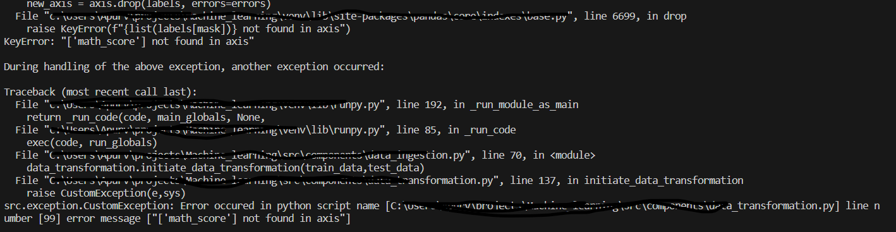

Check the column names written properly or not to solve the error.

To solve this, added “with_mean = False” in Standardscaler for numerical and categorical pipeline

#now to create a pipeline,

            numerical_pipeline = Pipeline(

                steps = [

                    ("imputer", SimpleImputer(strategy="median")) ,#for handeling the missing values

                    ("scaler", StandardScaler(with_mean=False))

                ]

categorical_pipeline = Pipeline(

                steps = [

                        ("imputer", SimpleImputer(strategy="most_frequent")),#missing values handeling for categorical features

                        ("one_hot_encoder", OneHotEncoder()),

                        ("scaler", StandardScaler(with_mean=False))

                        ]

                     )

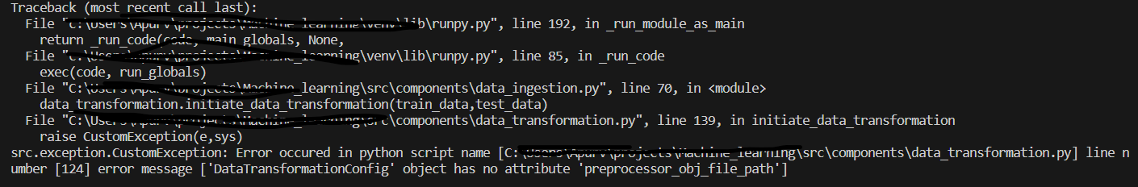

Check name of the object and use it properly.

save_object(

                file_path=self.data_transformation_config.preprocessor_ob_file_path, #file _path

                obj=preprocessor_obj #object

            )

All errors solved.

Output:

(preprocessor.pkl file got created. And logs got created)

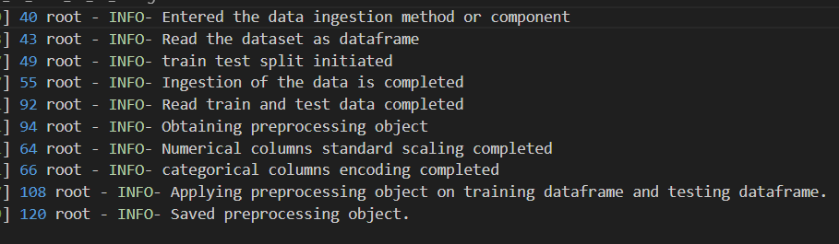  
  
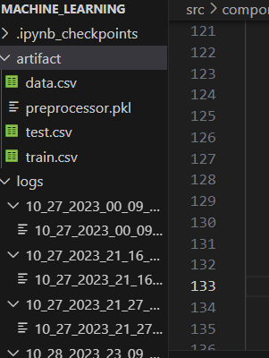

* In this tutorial we completed the data transformation part.
* We had so many different features, the main purpose of data transformation is feature engineering, data cleaning, we handled the missing values, numerical and categorical columns etc.
* In requirements.txt file we added “dill” library.
* We have combined data ingestion and data transformation.
* Saved all the files and committed the code in GitHub.